Practical Photography Group
by Peter Read
This newish group decided that the way to run the group was to have instruction in the morning and venture out with cameras in the afternoon.
The morning sessions so far have concentrated on control of the Aperture and the Shutter speed. For Aperture we were able to use an online simulation of the effect of altering the stop setting for any lens, subject or distance arrangement. The site address for this is http://dofsimulator.net/en/. For Shutter we examined the use of a slow speed shutter and using the panning technique.
In the afternoon about half the members came out stopping firstly for a lunch at Bridge Farm House cafe in Britford. Lovely food. Then into the sunshine [yes truly] to find ways of interpreting the lessons. The churchyard was the obvious place to test of Depth of Field with gravestones standing in wavy rows and leaning over.
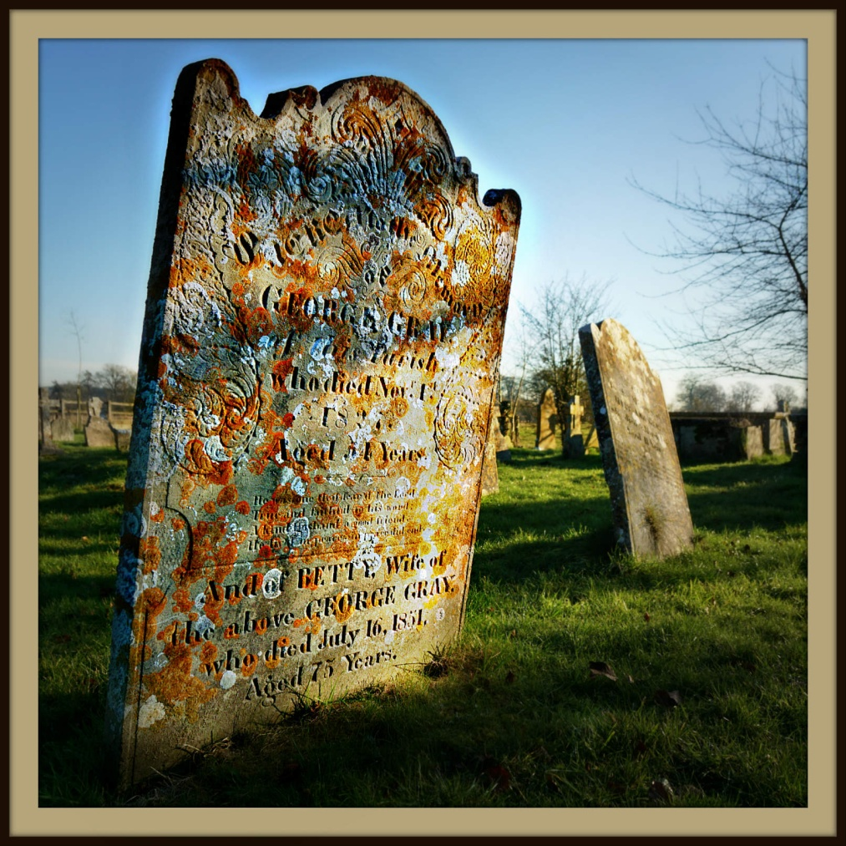
Britford Churchyard gravestones and below
Trunks and a Straw Dragon at Bridge Farm
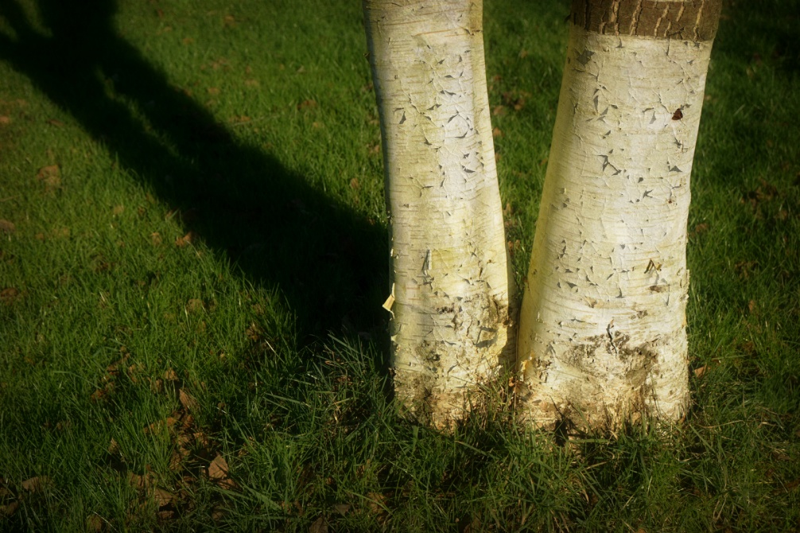
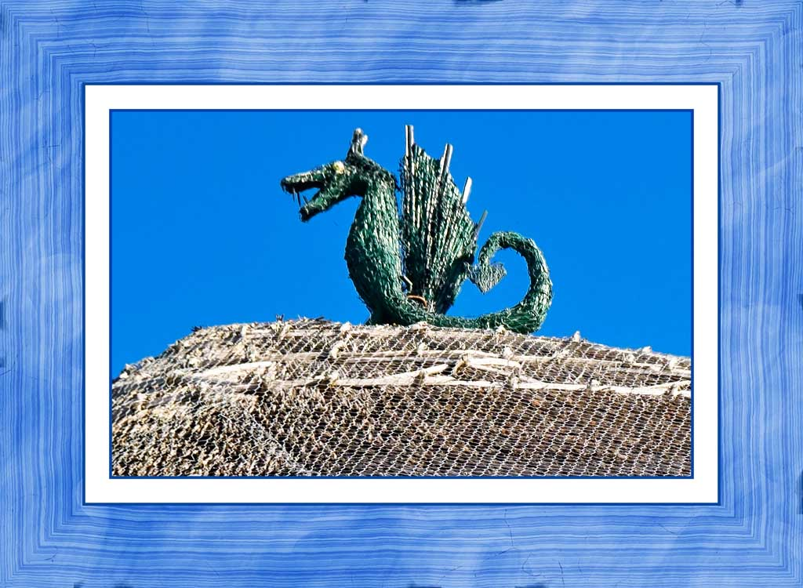
A good time was had by all and they came away with some interesting photographs that will be analysed at the next session which is on 17th February. You could still join this group if you wish to. Just contact Peter Read on 501218. We would love to help you improve your photography.#

