
Newsletter no 97
Spring 2015

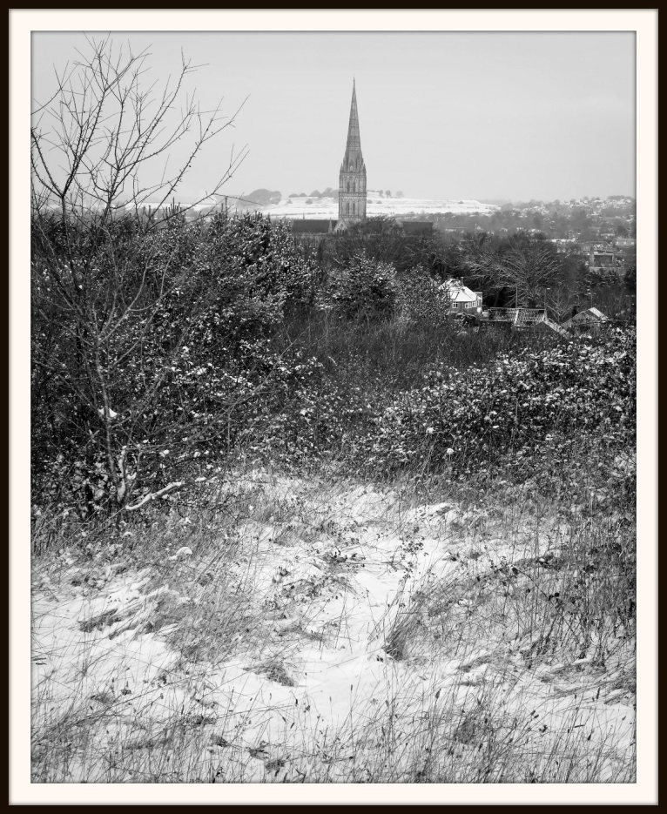
The Snowy Day! Peter Read
www.salisburyu3a.org/

From The Editors Desk
The weather cannot seem to make up its’ mind as to whether winter is over or not. A relatively mild and sunny day followed by showers of snow or hail. I have lots of crocus out in the garden, but no daffodils. I think they must have rotted with all the rain. My favourite primula are like jewels in the garden with their many colours and the rest of the bulbs are showing leaves and buds. There are buds showing on all the shrubs, so I think maybe the early Spring is a little shy this year!
As ever, we have had some very interesting talks over the last few months, for which we owe Pat Crossland many thanks and we wish both her and Bernard, also retiring as Treasurer, well in their retirement from the Committee. Andy Pool is also stepping down from the Committee and we would like to show our appreciation of his efforts with Hall Safety and managing the Sound system.
We would also like to show appreciation of all the work done by the unsung heroes . Eileen Forder has been Tea and Coffee Queen for some years now and has done a fantastic job and Alan has been stalwart support and has quietly helping out by putting out chairs on a regular basis. We also appreciate the
people who volunteer on a regular basis to help with serving tea and coffee and manning the lists at the door, a thankless task especially on the colder days, when people leave the door open!
Thanks also to the rest of the committee, who struggle through the year with the mundane tasks of running the meeting, trying hard to persuade people to volunteer to do the odd jobs. If everyone took a turn, you would only have to do it probably once a year! How about making this year the one when you volunteer for a job. It doesn’t take long and would give you a good feeling of having done something to help.
The AGM is coming up in April when we will need new people for the committee to replace the retirees.
Zelah Bysouth 01722 330307 zjbb@btinternet.com
New Members
We are pleased to welcome Mrs Mary Mitchell, Mr Richard Tremlett, Mr Frank Bryant and Mrs Mary Miles
Group Subjects not yet "on offer"
If you look around other U3As, both here in Salisbury and further afield, it soon becomes apparent that there are many many subjects, easily studied in the home environment, but at present not "on offer" to Spire U3A members simply because no-one is willing to act as group leader. I sincerely hope that, for the benefit of both current and new members, it will not be too long before volunteers come forward. I am making a start with the "Beginners Geology" proposed course (see details above) and sincerely hope that other subjects and leaders will be forthcoming as we move into 2015/16!.
Stuart Robson - Spire U3A Group Co-ordinator.
Spire U3A News from the Groups, March 2015
The time of year has come around again when I put pen to paper to draw up a report featuring Spire U3A's groups activities and fortunes over the past 12 months or so.
Last April I reported that some groups had ceased to operate - for a variety of reasons - and that new groups, either offering the same or similar subjects, or something fresh, had failed to materialise. Sadly, that trend has continued throughout the past year. The "Wine Appreciation" group ceased recently with Frank Woodward's "retirement" as leader and Mike Kirby's "Family History for Beginners" will not re-commence in September 2015, due to lack of interest. Ian Hobday is no longer offering computer help, again, the demand for this has largely ceased.
On a more positive note, the groups not ceasing, by all accounts continue to operate successfully. We still need new groups to offer to existing and new members. To this end I am proposing to run a "Geology for Beginners" group, to meet monthly on the 3rd Tuesday, 10.00 to 12.00. In anticipation of sufficient interest, the first meeting will be held on Tuesday, May 19th
Current Vacancies
On 19th February, 2015, I issued an e-mail to the Group Leaders to request details of vacancies, if any, and to report any other matters of general interest.
Information obtained so far :-Eileen Forder - Tea Dance. Eileen requests "More couples, please!" also "More gentlemen"!
Stella Tobi - Book Club. Room for 1or2 more participants.
Stuart Robson - Recorder Playing for Fun and Improvement. Could easily accommodate more players or beginners wishing to learn the instrument.
Peter Read - Various courses, with vacancies. (Science and Technology, Advanced Family History, Digital Imaging.)

Our DI Starters group finished on the 6th March. We will begin a new DI Starters in September.
Meanwhile we are starting yet another group called Using Your Camera. This starts on the Friday 3rd April 2015 at 10 am at 12 Chiselbury Grove. We shall start here but future lessons will be out and about.
Also our long running Further DI group has ceased and members have been invited to join with our DI Extra group.
Science and Technology Group
The next meeting will be at and on the Harnham Water Meadows. Arrive at Rose Cottage at 10 am on 30th March with Wellington Boots. First we shall have a 45 min talk from Jan Fitzjohn and then if desired we shall take a guided walk over the meadows.
On 27th April we will have a peek at how The Mobile Phone System works from Abi Oyepitan.
These are the groups where I have had confirmation from the Group Leaders. There are other groups I am sure could take on more members :-
Colin Seago - Walking Group.
Christine Hill – Canasta.
Alison Dawson - Playing Chamber Music.Do please contact the Group Leaders for further details and to ascertain the latest situation. Contact details are on the Spire U3A web-site or the notice board also on the paper list issued with your membership card.
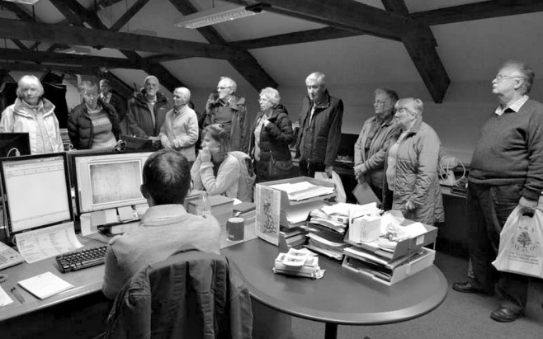
Peter Read
Spire U3A Family History (Advanced) visit to the Genealogy Magazine
At Manor Farm, Chilmark January 14th 2015
NEW GROUPS
by Peter Read 501218 or peterjread@ntlworld.com
We are starting a new Digital Imaging group that we are calling DI Extended. This is for those members who have been on our DI Starters course and wish to extend their capabilities. Other members can join in too. Members just need to have a desire to improve their photos beyond the straight forward processing. If Members contact me I will pencil their name in. The first session is on 27th March 10am at 12 Chiselbury Grove.

U 3 A Archaeology Group
You will be pleased to know that we now have 41 members on our list of people interested in being part of our Archaeology Group.
I'm sure you can understand that the organisation of such a large group is no small task and so with the spirit of U3A it is really necessary for everyone to contribute and participate in order to share the load.
So please put on your thinking caps and see what you could offer to do. You will not be alone - there is support and advice in doing this.
One thing that many people said they would like to do was research and it should be high on the list of what the group should be doing. We need more volunteers in this area but if you are short of ideas for a topic why not go round the museum galleries and let an artefact grab your imagination.
Several people wanted to be more hands on with digs and attached is information on 2 courses on Archaeology which could get you going. There is also information on both on websites.
Our schedule for March to June is now coming together:
10 March A visit to Devizes Museum (thank you Roger and Marlene for organising this)
!0.30am A volunteer guide will show us around the “Prehistoric Gallery” (£4.50 a head for the tour, entry to the Museum is free if you are a member of Salisbury Museum – don't forget your card) Roger says: It seems that Wilts and Dorset are still operating the number 2 route which now leaves from New Canal. The 8.55 service is scheduled to arrive in Devizes at 10.07. That might be attractive to members without their own transport or for those wishing to keep costs down by using a bus pass. I imagine that members using their own car and giving a lift to other members would make their own arrangements over sharing fuel costs. Also to agree on pick up and drop off points in Salisbury.
14 April A Speaker (TBA) (Thanks Ian for doing this) – Museum Lecture Room 10.30am
12 May Report on research by David Whetton and also by Eve Shillingford
10.30am Update on local digs (Museum Lecture Room)
9 June Visit to Down Farm (Thank you Jill) Martin Green's museum of finds and a walk
10.30am“Dr Martin Green’s farm on Cranborne Chase, “one of the most carefully studied areas in western Europe”.
WINDSOR CASTLE
Windsor Castle has been the home of 39 monarchs, and the appearance of the State Apartments today reflects the changing tastes of the Castle’s royal occupants – particularly Charles II (1660-1685) and George IV (1820-30). The State Apartments and Drawings Gallery are furnished with some of the finest works of art from the Royal Collection, including paintings by Rembrandt, Rubens and Canaletto – many of these still in the historic settings for which they were first collected or commissioned by the Kings and Queens who have lived at Windsor. Queen Mary’s Dolls’ House was built by Sir Edwin Lutyens between 1921-1924, and is filled with thousands of objects made by leading artists, designers and craftsmen – from life below stairs to the high-society setting of the saloon and dining room. St George’s Chapel is one of the finest examples of Gothic architecture in England and is noted for its magnificent stone fan vaulting. The tombs of ten sovereigns lie within the chapel.Our ticket includes audio guide free flow with entry to the State Apartments, St George’s Chapel, Queen Mary’s Dolls House and the Drawings Gallery.
Please note: On arrival, you and your belongings will be subject to airport-style security checks.
COST £30 PER PERSON
To include coach travel, entry fee and driver gratuity.Payment by cheque payable to “Sarum U3A Visits Account”before 28 February 2015 please. No cash. Please write destination on back of cheque. Depart London Road Park & Ride 8.30 a.m. Return London Road Park & Ride 6.00 p.m. approx
BOOKING FORM : PLEASE REPLY BEFORE 28 FEBRUARY 2015
Name: email:
Tear off booking form and send with cheque to: Judith Copeland, Field End, Hackthorne Corner, Durrington SP4 8AS. Enquiries: Phone Judith on 01980 655665 or Maureen Pardy 01722 504295
Date | Destination |  | Possible cost  if coach full
1. Tues 21 April | Windsor Castle |  | £30
3. Wed 10 June | Three Rivers Cruise (Hamble, Test and Itchen) |  | £30
4. Thurs 2 July | Hampton Court RHS Flower Show |  | £45
5. Mon 7 September | Osborne House, Isle of Wight and scenic coastal drive |  | £30  (Free entry for EH members)

Payment by cheque only made payable to “Sarum U3A Visits Account” as soon as possible. No cash. Please write destination on back of cheque
Roman Devon Field School This fifth season of excavation at Ipplepen in Devon, run by the University of Exeter, will return to the Roman road and associated late and post-Roman cemetery revealed in 2011 and 2014. This part of the site has twice been featured on the BBC ‘Digging for Britain’ programme (series 2, 2011; Series 4, 2015). This cemetery forms part of the largest Romano-British settlement in Devon outside of Exeter. Geophysical survey and a significant number of Roman coin finds have highlighted the importance of this extensive site and its potential to explore the relationship between Roman Britain and its native population. Previous field schools have revealed an Iron Age roundhouse and further Romano-British features, along with evidence for Neolithic activity.
The dig is supported by the University of Exeter, the Portable Antiquities Scheme, the British Museum and Devon County Council.This year’s field school will run in 26th-31st July 2015; the cost per week is £200 (excluding accommodation and food). Participants are invited to take part for a minimum of 1 week. The working week will be 9am-5pm, Sunday to Friday. The first week will commence on Monday 6th July and end on Sunday 12th, with Saturday 11th as a day off. Past fieldwork experience is not essential, but participants should be at least 18 years old. Accommodation is not included, but reduced rates at a local campsite have been arranged. Places are limited, so early booking is recommended.

March Sudoku

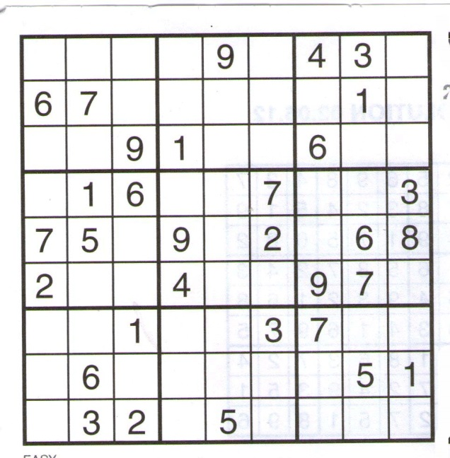

Conformity
Conform where we must
Inform where we can
And confirm only good
Where this is meant
For the general content
Best for the whole
Should be our end goal
I confirm
I conform
I’m content

Observations
Arthur Baskerville of Spire U3A has published a new volume of poems, inspired by a lifetime’s observations. Making Tracks is published by Downland Press at £5.95
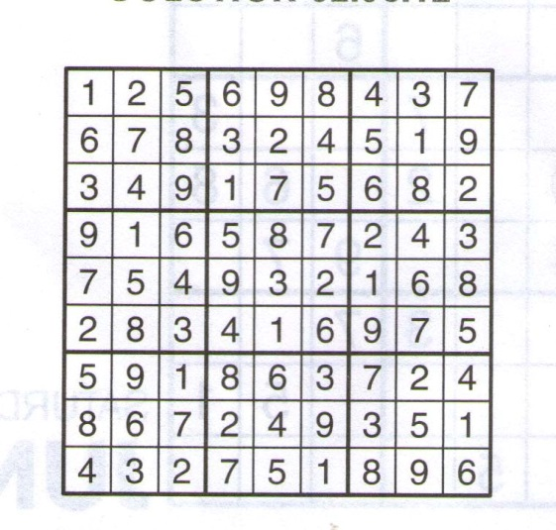
March Sudoku Solution

